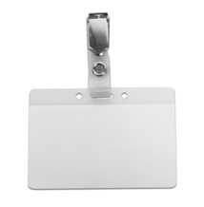

Add your first and last name to the name badge below. It can then be printed, trimmed,   
and slid into a name badge holder (see above), which can be purchased at an office supply store.



**Your Name Here**

**WHOlives** Ambassador/Trainer